# Data report

# - Swiss TPH -

## Testing Center:

Swiss Tropical and Public Health Institute (Swiss TPH)

Socinstrasse 57

4002 Basel

Switzerland

## Person of contact:

Sergio Wittlin

Tel +41-61-284-8136

sergio.wittlin@unibas.ch

## Team

|  |  |
| --- | --- |
| Principle investigator (Swiss TPH) | Dr. Sergio Wittlin |
| Experimental technicians (Swiss TPH) | Christoph Fischli/Ursula Lehmann/Sibylle Sax |
| Project Director (MMV) | Dr. Didier Leroy |
| Research Scientist (MMV) | Dr. Xavier Ding |

## Study requested by

|  |  |
| --- | --- |
| Project Director (MMV) | Dr. Paul Willis |

## Goals of the study

To investigate in a SCID mouse model of human malaria the *in vivo* efficacy of antimalarial lead compounds.

## Key findings and conclusions

*Plasmodium falciparum* was tested in NODscidIL2Rγnull mice engrafted with human erythrocytes. The antimalarial efficacy of MMV669844 was assessed using a 4-day-treatment regimen (dosings administered once a day for 4 consecutive days) and blood parasitemia was quantified by FACS analysis (on days 3, 5, 6 and 7 post-infection) and microscopic analysis of Giemsa-stained blood smears (on days 3 and 7 post-infection). Figures 1 and Tables 1+2 summarize the *in vivo* efficacy test results following oral (p.o.) administration. At 4 × 50 mg/kg p.o. the average *in vivo* activity in n=2 mice was >99.9% when compared to n=4 untreated control animals.

The sensitivity cut-off for the parasitemia determination by FACS was found to be 0.3%. Therefore, for parasitemia <0.3% the data shown in this report is the one obtained by microscopy on days 3 and 7 post-infection. In the short term (next campaign) it will be the goal to have parasitemia data determined by microscopy for the entire treatment week. And in the longer term, it is the goal to increase the sensitivity of the FACS methodology with the help of the GSK team.

## Description of the assay

## General assay principle:

This protocol is performed in the group of Dr. Sergio Wittlin at Swiss TPH (Unit of Prof. Pascal Mäser), for assessing compound efficacy against the *Plasmodium falciparum* strain *Pf3D70087/N9 in vivo.* Mice are infected intravenously with parasitized red blood cells on day 0. Experimental mice are generally treated at day 3, 4, 5, and 6 post-infection with an oral dose of the compound (4-day test by Peters) and are compared to an infected control group for reduction in parasitemia on day 7. Other delivery routes (intravenous, intraperitoneal, subcutaneous) and dosing regimens (e.g. single dose) are possible.

## Compound form and quantity needed:

50mg is enough for a dose response study in quintuplicate with doses of 50mg/kg and decreasing. Compounds should be provided as weighed powder (accuracy of 2 digits after the comma) together with MW and information about salt/parent forms and solvent to use if not DMSO.

## Throughput:

Experiments with n=18 mice can be tested per month.

## SOP:

***Plasmodium falciparum* acute *in vivo* model, 4-day test by Peters**

**Parasite strain:** *Plasmodium falciparum* strain *Pf3D70087/N9*

Reference:

María Belen Jimenez-Díaz, Teresa Mulet, Sara Viera, Vanessa Gomez, Helen Garuti, Javier Ibanez, Angela Alvarez-Doval, Leonard D. Shultz, Antonio Martínez, Domingo Gargallo-Viola, and Inigo Angulo-Barturen.

Improved Murine Model of Malaria Using Plasmodium falciparum Competent Strains and Non-Myelodepleted NOD-scid IL2Rgammanull Mice Engrafted with Human Erythrocytes.

Antimicrobial Agents and Chemotherapy, 2009, 53:4533

**Standard drugs:** Chloroquine (Sigma C6628**)**

**Drug preparation:** Compounds are solubilised (suspended) in a solution consisting of 70% Tween-80 (d= 1.08g/ml) and 30% ethanol (d=0.81g/ml), followed by a 10-fold dilution in H2O.

**Mice:** *NODscidIL2Rγnull* mice, females, 20 - 22 g

**Cages:** Standard Macrolon cages type II

**Maintenance:** Mice are kept in individually ventilated cages (IVC), but otherwise under standard conditions with 22°C and 60 – 70 % relative humidity, pellets (PAB45 – NAFAG 9009, Provimi Kliba AG, CH-4303 ,Kaiseraugst, Switzerland) and water *ad libitum*.

**Test procedure:**

Day 0From a donor mouse with approximately 5-10% parasitemia, heparinized blood (containing 100 microliter of 200 u/ml Heparin) is taken and diluted in physiological saline to 108  parasitized erythrocytes per ml. Of this suspension, 0.2ml is injected intravenously (i.v.) into experimental groups and a control group of n=3-5 mice.

Day 3 - 6 3, 4, 5 and 6 days post-infection, the experimental groups are treated with a single daily dose by the oral (po) route. Other routes of application are possible. The drug concentration is adjusted in a way that 10ml/kg has to be injected.

Day 3, 5, 6 and 7 3, 5, 6 and 7 days post-infection, 2 microliter tail blood is taken and parasitemia as well as hematocrit determined by FACS. On days 3 and 7 parasitemia is also determined by microscopy on >10'000 red blood cells.

The difference of the mean infection rate of the control group (= 100%) to the test group is calculated and expressed as percent reduction. As an example, activity determination with a mean of e.g. 2% parasitemia in treated mice and a mean of e.g. 40% parasitemia in the control animals is calculated as follows: (40%-2%)/40% *100= 95% activity.

The results are expressed as reduction of parasitemia on day 7 in % as compared to the untreated control group.

## Results

The compound was solubilised (suspension, milky) in a solution consisting of 70% Tween-80 and 30% ethanol, followed by a 10-fold dilution in H2O. The therapeutic efficacy of MMV669844 against *P. falciparum* *in vivo* is illustrated in Figure 1 and Tables 1-2.

**Figure 1: Therapeutic efficacy of MMV669844 against *P. falciparum Pf3D70087/N9.*** The arrows indicate the days of treatment in the 4-day test by Peters. Values are the level of parasitemia in peripheral blood of n=2 mice/group.

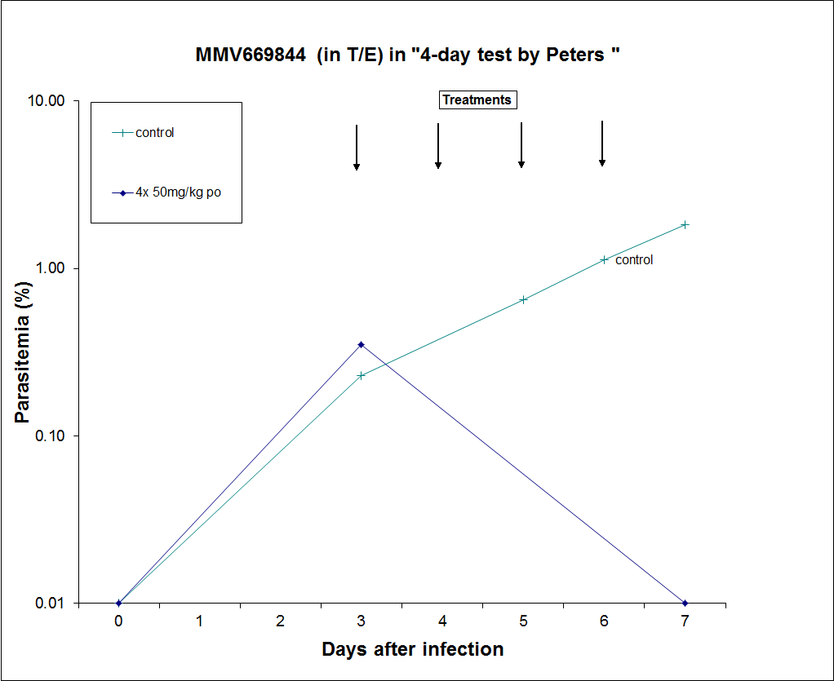

Table 1: Average parasitemia values used for Figure 1.



Table 2: *In vivo* efficacy of MMV669844 against *P. falciparum Pf3D70087/N9*. Shown are all values of parasitemia on day 7 post-infection.



